Media Catalog Android App
Name: Santanu Ghosh
Intelligent Device Technologies ITM-555 Spring 2011
Illinois Institute of Technology
Chicago, IL

The Media Catalog Android app is an application for cataloging personal media – Audio, Video, Books, and Games.
Known bugs: The export/import to and from CSV file is broken. The Categories feature is broken.
- When the app is started we get the splash page as shown below.
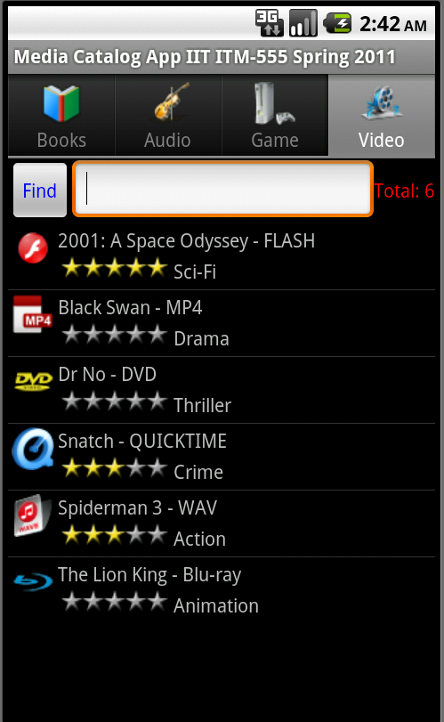
There are 4 tabs for 4 different media categories – Books, Audio, Game, Video
There is a text box to search for media (by its name) within a category. The “Total:” gives the total number of items within a category.
The list below the search box shows the various items stored within the category and the media type along with its rating (as defined by the user when entering the media).

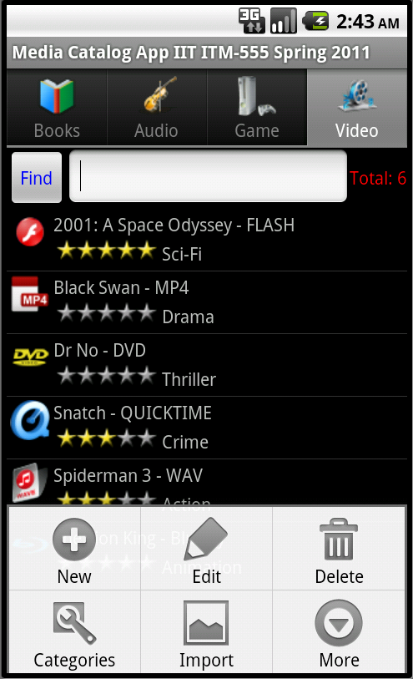
Pressing the “Menu” button displays the menu options as shown above. There are buttons to enter New data, Delete existing data, Edit existing data, defining the Categories (not working), Importing data from a CSV file (not working).

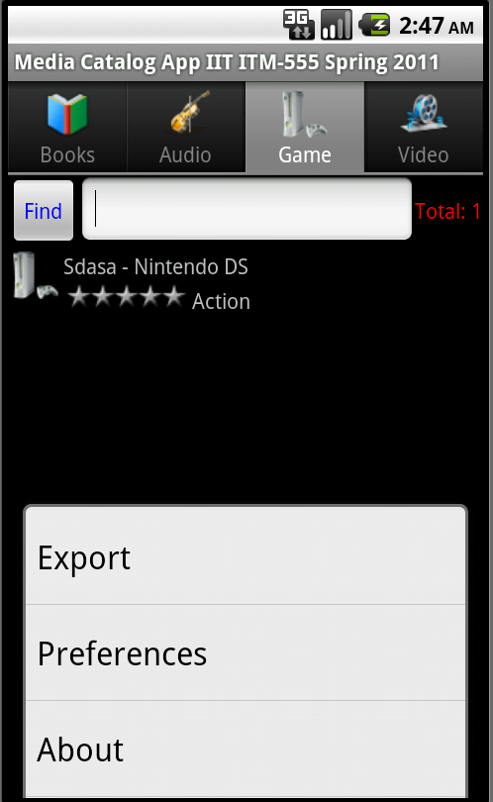
The “More” options gives the above options
- Export to CSV file (not working), user
- Preferences for setting the Tabs, and
- finally the “About” screen.

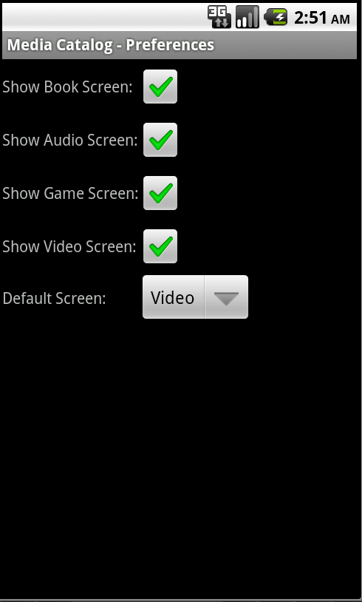
The screen above shows the option for setting the Media tab preferences in the main screen. The user can define which tabs to display on the Main Scren and in which order.

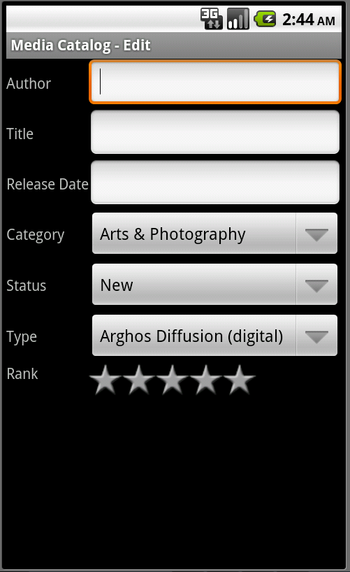
The screen above shows a typical screen for entering or editing data. The screen above is for entering /editing Book information. Corresponding screens for the other media types have their own relevant fields.

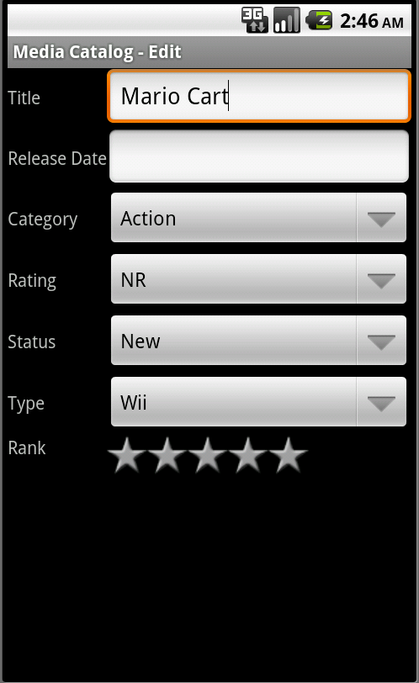
Above screen shows new game data being entered. Similar entry screens exists for other media types.

